Exercise #1: Create Visit Notification flow

**Objective:** In this exercise, you will create a Power Automate flow that implements the requirement. The visitor should be sent an email that includes the unique code assigned to the visit when a visit is created.

1. Task #1: Create a flow
2. Navigate to [https://make.powerapps.com](https://make.powerapps.com/). You may need to reauthenticate - click **Sign in** and follow instructions if needed.
3. Select your **[my initials] Practice** environment at the top right if it is not already selected.
4. In the left navigation, select **Flows**.
5. If prompted, select **Get started**.
6. Click **New flow** and select **Automated cloud flow**.
7. Enter “Visit Notification” for **Flow name**.
8. In **Choose your flow’s trigger**, search for **Dataverse**.
9. Select the trigger **When a row is added, modified or deleted**, and then click **Create**.
10. Populate the trigger conditions for the flow:
    1. Select **Added** for **Change type**
    2. Select **Visits** for **Table name**
    3. Select **Organization** for **Scope**
    4. On the trigger step, click the ellipsis (**…**) and click **Rename**. Rename this trigger **“When a visit is added”**. This is a good practice, so you and other flow editors can understand the purpose of the step without having to dive into the details.
11. Task #2: Create a step to get the visitor row
12. Select **New Step**. This step is required to retrieve visitors information, including email address.
13. Search for **Dataverse**.
14. Select the **Get a row by ID** action.
15. Select **Contacts** as **Table name**
16. Select the **Row ID** field. Notice that a window pops up to select Dynamic content or Expressions.
17. In the **Row ID** field, select **Visitor (Value)** from the Dynamic content list. In this step, you are looking up the Contact for the Visit row that was created to trigger this flow. Since email address is part of the Contact table, you will need this information to send the email to the visitor.
18. On this action, click the ellipsis (**…**) and click **Rename**. Rename this action **“Get the Visitor”**. This is a good practice, so you and other flow editors can understand the purpose of the step without having to dive into the details.
19. Task #3: Create a step to send an email to the visitor
20. Click **New Step**. This is the step that will send an email to the visitor.
21. Search for *mail*, select **Office 365 Outlook** connector and **Send an email (V2)** action.
22. If asked to Accept terms and conditions for using this action, click **Accept**.
23. Select **Add dynamic content** under the **To** field.
24. Select **Email** from the Dynamic content list. > Notice that it is beneath the **Get the visitor** header. This means you are selecting the Email that is related to the Visitor that you looked up in the previous step.
25. Enter **Your scheduled visit to Bellows College** in the **Subject** field.
26. Enter the following text in **Email Body**:

Dynamic content needs to be placed where fields are named in brackets. It is recommended to copy & paste all text first and then add dynamic content in the correct places.

CodeCopy

Dear {First Name},

You are currently scheduled to visit Bellows Campus from {Scheduled Start} until {Scheduled End}.

Best regards,

Campus Administration

Bellows College

1. Highlight the **{First Name}** text. Replace it with the **First Name** field from the **Get the Visitor** step.
2. Highlight the **{Scheduled Start}** text. Replace it with the **Scheduled Start** field **When a visit is added** step.
3. Highlight the **{Scheduled End}** text. Replace it with the **Scheduled End** field from the **When a visit is added** Step.
4. Click **Save**.

Leave this flow tab open for the next task. You flow should look approximately like the following:

[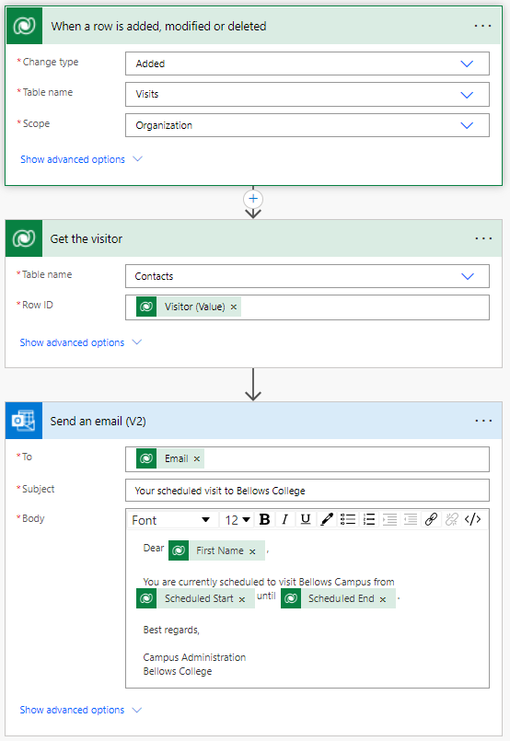](https://microsoftlearning.github.io/PL-900-Microsoft-Power-Platform-Fundamentals/Instructions/Labs/media/4-Flow.png)

1. Task #4: Validate and test the flow
2. Open a new tab in your browser and navigate to [https://make.powerapps.com](https://make.powerapps.com/).
3. Select your **[my initials] Practice** environment at the top right if it is not already selected.
4. Click **Apps** and select the **Campus Management Model-driven** app you created earlier.
5. Leaving this browser tab open, navigate back to the previous tab with your flow.
6. On the command bar, click **Test**. Select **Manually** and then click **Test**.
7. Navigate to the browser tab with your model-driven app open.
8. Using the navigation on the left, select **Visits**
9. Press the **+ New** button to add a new **Visit** record.
10. Complete the Visit record as follows:
    * **Name:** Test Visit
    * **Visitor:** John Doe
    * **Scheduled Start:** Tomorrow at 8:00 AM
    * **Scheduled End:** Tomorrow at 9:00 AM
11. Select the **Save and Close** button.
12. Navigate to the browser tab with your flow test running. After a short delay, you should see the flow running. This is where you can catch any issues in the flow or confirm that it ran successfully.

After a short delay, you should see an email in your inbox, since you populated John Doe’s email as your personal email. Note that it may go to your Junk Email folder.

Challenges

* Play around with the formatting on the email. How can you make it more professional looking?